***Abanob Evram***

***Assignmen1***



**[Q1]**

**The code:**

module Mux2(in0,in1,sel,out);

input in0,in1,sel;

output out;

assign out=(sel==1)?in1:in0;

endmodule

module Q1(A,B,C,D,E,F,Sel,Out,Out_bar);

input A,B,C,D,E,F,Sel;

output Out,Out_bar;

wire z0,z1;

assign z0 =A&B&C ;

assign z1=~(D^E^F);

Mux2 m1(.sel(Sel),.in0(z0),.in1(z1),.out(Out));

assign Out_bar=~(Out);

endmodule

**Another Code :**

module Q1(A,B,C,D,E,F,sel,out,outbar);

input A,B,C,D,E,F,sel;

output out,outbar;

wire z1,z0;

assign z0=A&B&C;

assign z1=~(D^E^F);

assign out=(sel==1)?z1:z0;

assign outbar=~(out);

endmodule

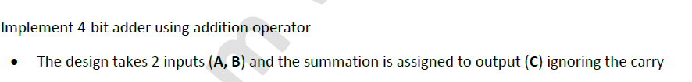**[Q2]**

**The code:**

module adder4(A,B,C);

input [3:0] A,B;

output [3:0] C;

assign C =A+B ;

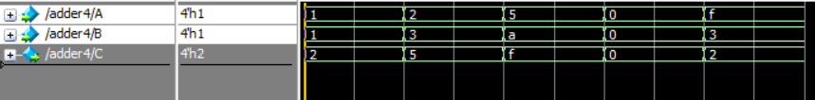endmodule

**[Q3]**

**The code:**

module Decoder2(A,D);

input [1:0] A ;

output reg [3:0] D;

always @(*) begin

if (A==0)

D='b0001;

else if (A==1)

D='b0010;

else if (A==2)

D='b0100;

else if (A==3)

D='b1000;

end

endmodule

**[Q4]**

**The code:**

module evenparity(A,Out_with_parity);

input [7:0]A ;

output [8:0] Out_with_parity;

wire parity_bit;

assign parity_bit = ^A;

assign Out_with_parity ={A,parity_bit} ;

endmodule

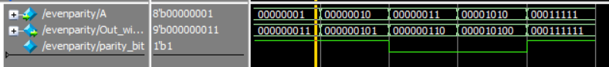

**[Q5]**

**The code:**

module comparator2(A,B,greater,equal,less);

input [3:0] A,B;

output reg greater,equal,less;

always @(*) begin

if (A>B) begin

greater=1;

equal=0;

less=0;

end

else if (A==B) begin

greater=0;

equal=1;

less=0;

end

else if(A<B)begin

greater=0;

equal=0;

less=1;

end

end

endmodule